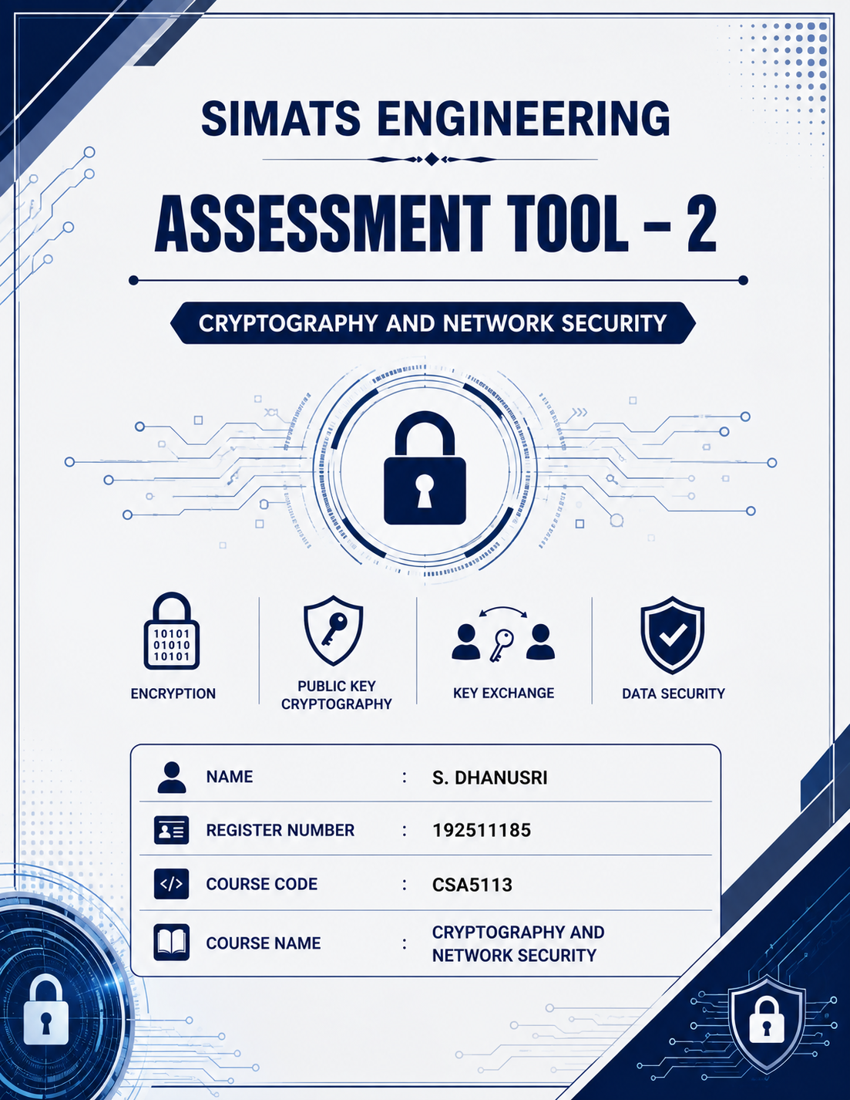

1. Secure Data Transmission using Block Cipher
A. Explain why this issue occurs.
Electronic Code Book (ECB) mode encrypts each plaintext block independently using the same secret key. When two or more plaintext blocks contain identical data, they produce identical ciphertext blocks after encryption. As a result, repeated patterns in the plaintext remain visible in the ciphertext.
In the given scenario, the company is transmitting repeated financial data blocks. Since many financial records contain similar information, ECB mode generates identical ciphertext blocks. An attacker observing the encrypted data can identify repeated patterns and gain information about the structure of the original message, even without knowing the secret key. This makes ECB unsuitable for transmitting sensitive financial information because it does not provide complete confidentiality.
B. Suggest a more secure block cipher mode and justify your choice.
The most suitable block cipher mode for this scenario is Cipher Block Chaining (CBC) mode.
In CBC mode, before encrypting each plaintext block, it is XORed with the previous ciphertext block. For the first block, a randomly generated Initialization Vector (IV) is used. This chaining process ensures that identical plaintext blocks produce different ciphertext blocks.
CBC hides repeated patterns, making cryptanalysis much more difficult. Since financial information is highly confidential, CBC provides stronger security than ECB by preventing attackers from identifying repeated data. Therefore, CBC is the preferred mode for secure financial data transmission.

Conclusion:
Hence, CBC mode provides better confidentiality than ECB because it removes repeated ciphertext patterns and offers stronger protection for sensitive financial data.

2. Choosing an Encryption Algorithm for Banking System
A. Identify the most suitable algorithm.
Among DES, 3-DES and Blowfish, the most suitable encryption algorithm is Blowfish.
B. Justify your choice based on security strength and efficiency.
A banking application requires strong security while maintaining good performance.
- DES uses a 56-bit key, which is vulnerable to brute-force attacks and is no longer considered secure.
- 3-DES increases security by encrypting data three times, but this also increases processing time, making it slower.
- Blowfish supports variable key sizes ranging from 32 bits to 448 bits, providing stronger encryption with faster execution than 3-DES.
Blowfish is efficient, reliable, and suitable for encrypting large numbers of customer transactions. It provides high security while maintaining better performance, making it ideal for banking applications.
Conclusion:
Therefore, Blowfish is the most appropriate encryption algorithm because it offers strong security, flexible key sizes, and better performance than DES and 3-DES.

3. Key Exchange in an Unsecured Network
A. Explain how the Diffie–Hellman key exchange works.
Diffie–Hellman is a public key cryptographic algorithm used to establish a shared secret key between two users communicating over an unsecured network.
The process is as follows:
- Both users agree publicly on a large prime number (P) and a generator (G).
- User A selects a private key (a) and User B selects another private key (b).
- User A calculates the public key using A = Gᵃ mod P and sends it to User B.
- User B calculates the public key using B = Gᵇ mod P and sends it to User A.
- User A computes the shared secret using Bᵃ mod P.
- User B computes the shared secret using Aᵇ mod P.
Both users obtain the same secret key without transmitting it over the network. This shared key can then be used for secure communication.
B. Identify a possible security threat and suggest a solution.
A major threat to Diffie–Hellman is the Man-in-the-Middle (MITM) attack.
During this attack, an attacker intercepts the exchanged public keys and replaces them with fake public keys. As a result, both users unknowingly establish separate secret keys with the attacker instead of with each other.
This attack can be prevented by using Digital Signatures, RSA Digital Certificates, or a Public Key Infrastructure (PKI) to authenticate the exchanged public keys. Authentication ensures that both users communicate with the intended person and not with an attacker.
Conclusion:
Thus, Diffie–Hellman provides secure key exchange, but authentication mechanisms are essential to prevent Man-in-the-Middle attacks.

4. Public Key Cryptography for Email Security
A. Describe how RSA can be used for encryption and decryption.
RSA is an asymmetric encryption algorithm that uses two different keys: a Public Key and a Private Key.
When a sender wants to send a confidential email, the email is encrypted using the receiver's public key. Since only the receiver possesses the corresponding private key, only the receiver can decrypt and read the message.
For authentication, the sender creates a Digital Signature using their private key. The receiver verifies this signature using the sender's public key. This ensures confidentiality, authentication, message integrity, and non-repudiation.
B. Explain how key distribution and management play a role in maintaining security.
Proper key management is essential for RSA security.
Public keys should be distributed through trusted Certificate Authorities (CAs) so that users can verify their authenticity. Private keys must remain confidential and should never be shared. Organizations should securely store private keys, regularly update encryption keys, and revoke compromised certificates when necessary.
Effective key management prevents unauthorized access, protects confidential information, and ensures secure email communication.
Conclusion:
Hence, RSA provides secure email communication by ensuring confidentiality, authentication, integrity, and proper key management.

5. Cryptography for IoT Devices
A. Analyze the constraints of IoT devices.
IoT devices such as smart home sensors have limited hardware resources. Their major constraints include:
- Limited processing power
- Limited memory capacity
- Low storage space
- Low battery power
- Limited computational capability
- Requirement for real-time communication
- Low bandwidth availability
Because of these limitations, IoT devices require lightweight cryptographic algorithms that consume less power and processing time while maintaining strong security.
B. Recommend a suitable cryptographic approach and justify your answer.
The most suitable cryptographic approach is Elliptic Curve Cryptography (ECC).
ECC provides the same level of security as RSA while using much smaller key sizes. For example, a 256-bit ECC key provides security equivalent to a 3072-bit RSA key.
Smaller key sizes reduce memory usage, computational cost, communication bandwidth, and battery consumption. These advantages make ECC highly suitable for low-power IoT devices used in smart home systems.
ECC enables secure communication while maintaining high efficiency, making it the preferred cryptographic algorithm for IoT applications.
Conclusion:
Therefore, ECC is the best cryptographic solution for IoT devices because it offers strong security with smaller key sizes, faster computation, and lower power consumption.

